**Chapter 3: Waves**

**All Lectures Uploaded on YouTube:** [**https://tinyurl.com/fkm10-physics**](https://tinyurl.com/fkm10-physics)



A wave is a repeating disturbance or vibration that moves through a medium (or space), transferring energy from one location to another without the physical transfer of matter. Waves are fundamental to understanding natural phenomena such as sound, light, water motion, and even earthquakes.

# **12.1 Wave Motion**

Wave motion occurs when energy is transmitted from one point to another by the oscillations of particles or fields. Depending on the type of wave, particles of the medium may move perpendicularly or parallel to the direction of propagation.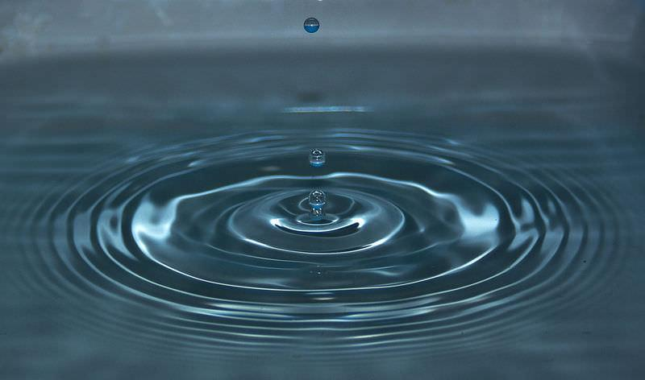

## **12.1.1 Water Waves** Water waves are generated when a disturbance, such as dropping a stone into water, creates ripples that travel outward in circular patterns. The particles of water move up and down in place, while energy moves across the surface. This illustrates that waves transfer energy but not matter.

## **12.1.2 Sound Waves**

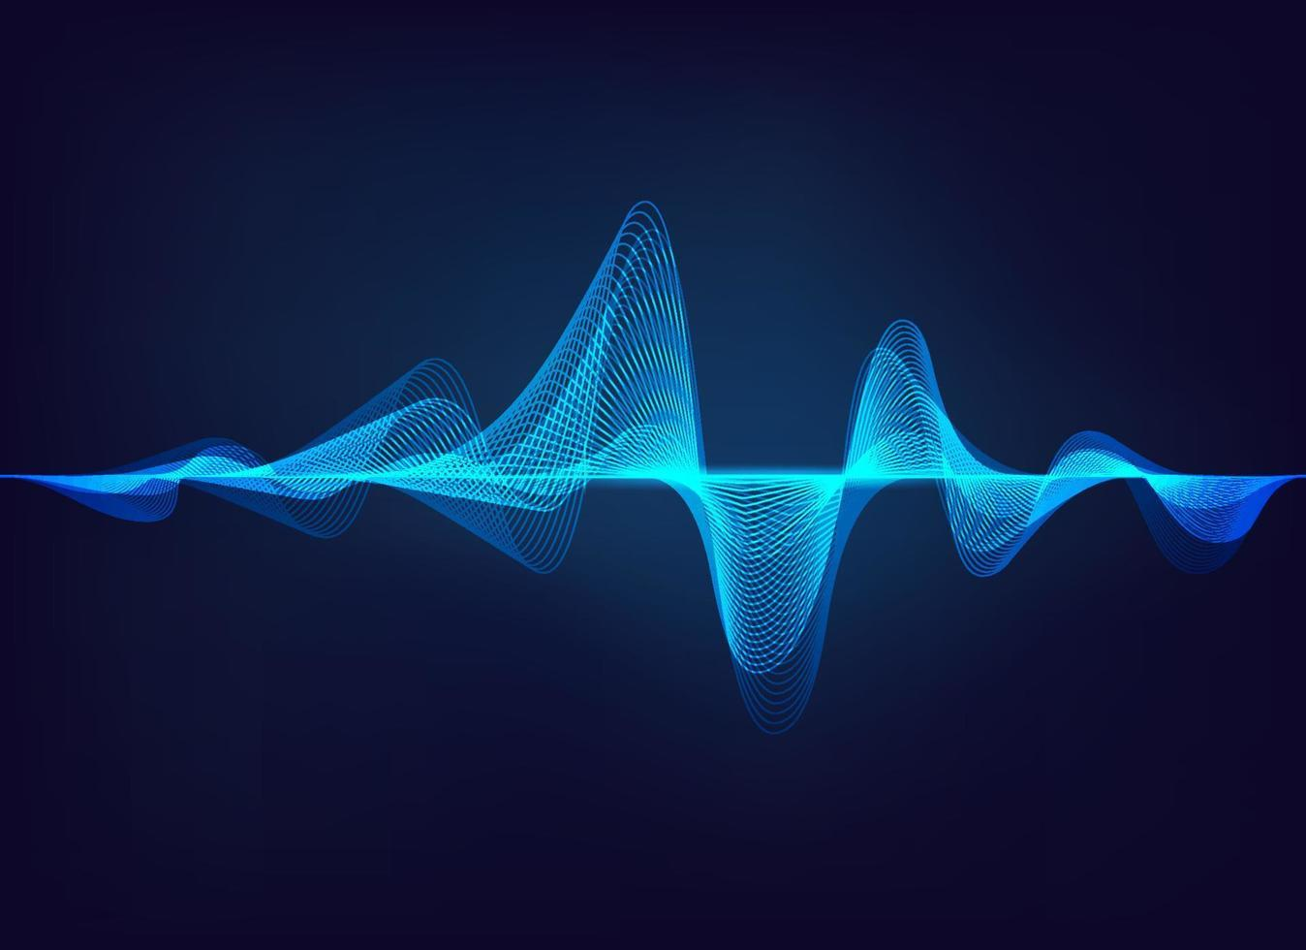

Sound waves are longitudinal waves caused by vibrations of objects like vocal cords. These vibrations cause compressions and rarefactions of air molecules that propagate through the medium. Although air molecules oscillate, they do not travel with the wave; only energy is transferred.

## **12.1.3 Electromagnetic Waves**

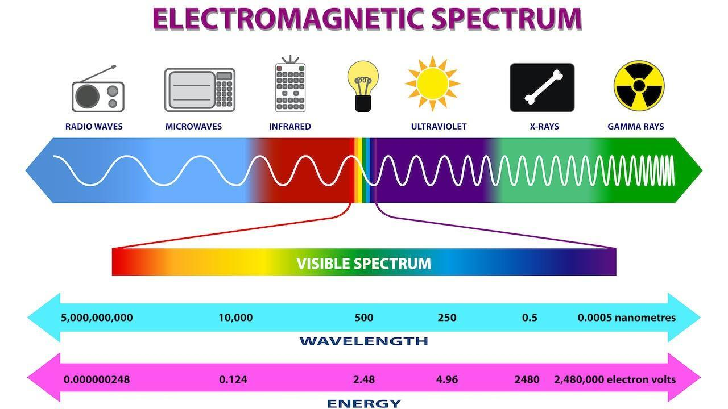

Electromagnetic (EM) waves consist of oscillating electric and magnetic fields at right angles to each other and to the direction of wave propagation. They do not require a medium and can travel through a vacuum. Examples include light, radio waves, X-rays, and microwaves.

## **12.1.4 Wave in Rope**

When one end of a rope is shaken, transverse waves form along its length. The particles of the rope vibrate perpendicular to the direction of wave motion, clearly showing how energy is transmitted without mass transfer.

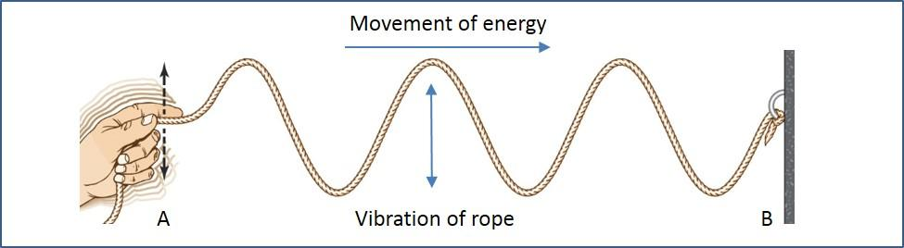

# **12.2 Wave Propagation**

Wave propagation refers to how a wave travels through a medium or space.

## **12.2.1 Oscillation**

Oscillation is the periodic back-and-forth motion of particles around their mean positions. In waves, these oscillations can be longitudinal (parallel to propagation, e.g., sound waves) or transverse (perpendicular, e.g., water and EM waves).

## **12.2.2 Energy Transfer**

The oscillations of particles allow energy to be transmitted from one particle to another. For example, in sound waves, kinetic and potential energy is passed along the medium as compressions and rarefactions.

## **12.2.3 No Net Movement**

Despite oscillating during wave passage, particles return to their original equilibrium positions. Thus, waves transport energy but not matter. For example, a cork on water bobs up and down but does not move outward with ripples.

# **12.3 Characteristic Wave Parameters**

## **12.3.1 Wavelength**

Wavelength **(symbol: λ)** is the shortest distance between two consecutive points in the same phase, such as crest to crest or trough to trough. It determines the scale of the wave and is measured in **meters (m)**.

Formula: $λ=\frac{v}{f}$

## **12.3.2 Wavefront**

A wavefront is the locus of points vibrating in the same phase. For example, in water ripples, the concentric circles are wavefronts. Wavefronts may be plane, circular, or spherical depending on the source.

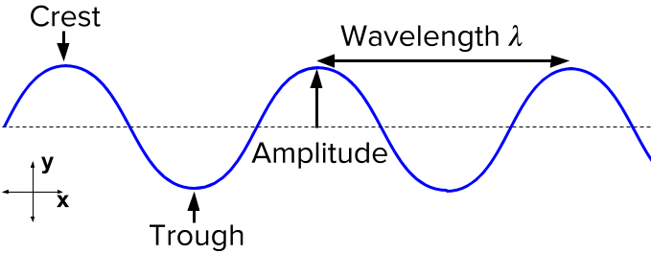

## **12.3.3 Wave Crest and Trough**

The crest is the highest point of displacement above the mean position, while the trough is the lowest point below it. They are characteristic features of transverse waves.

## **12.3.4 Displacement**

Displacement **(symbol: x)** is the distance of a particle from its mean (rest) position at any point in time. It is **measured in meters (m)** and varies with time during oscillations.

## **12.3.5 Amplitude**

Amplitude **(symbol: A)** is the maximum displacement from the mean position. It reflects the energy carried by a wave: greater amplitude means higher energy. It is **measured in meters (m)**.

## **12.3.6 Time Period**

Time period **(symbol: T)** is the time taken to complete one full oscillation or wave cycle. It is **measured in seconds (s**).

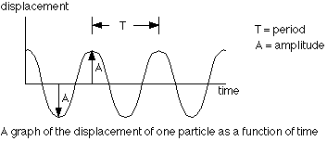

## **12.3.7 Frequency**

Frequency **(symbol: f)** is the number of complete cycles occurring per second. It is **measured in Hertz (Hz)**.

Formulae: $f=\frac{1}{T}$

$f=\frac{v}{λ}$

## **12.3.8 Relation between Time Period and Frequency**

Frequency and time period are reciprocals of each other: $T=\frac{1}{f}$. This means higher frequency corresponds to shorter time periods.

# **12.4 Waves and Their Types**

Waves can be classified according to how they propagate and what medium they require. By studying both energy transfer and particle oscillations, we distinguish between different wave types.

# **12.5 Types of Waves based on Medium**

• Mechanical Waves: Require a material medium to propagate. Examples include sound waves, water waves, and seismic waves.  
 • Electromagnetic Waves: Do not require a medium and can travel through a vacuum. Examples include visible light, radio waves, and X-rays.

# **12.6 Types of Waves based on Propagation**

## **12.6.1 Transverse Waves**

In transverse waves, particles of the medium vibrate perpendicular to the direction of wave travel. Examples include electromagnetic waves, surface water waves, and seismic S-waves. These waves exhibit crests and troughs.

**Examples of Transverse Waves:**

**Electromagnetic Waves**

* Electromagnetic (EM) waves are transverse in nature.
* They consist of mutually perpendicular oscillating **electric and magnetic fields**, with both fields also perpendicular to the direction of wave travel.
* EM waves **do not require a medium** and can travel through a vacuum.
* Examples: Radio waves, microwaves, visible light, ultraviolet rays, X-rays.

**Waves on the Surface of Water**

* Water waves at the surface are a mixture of transverse and longitudinal motion, but the vertical (up–down) oscillations of particles dominate.
* Energy moves outward as ripples while water particles mainly move up and down in place.
* They clearly demonstrate that **matter does not travel with the wave**, only energy.

**Seismic S-Waves**

* Secondary (S) waves are seismic transverse waves produced during earthquakes.
* They make the ground move **sideways or up and down**, perpendicular to the direction of travel.
* S-waves **cannot pass through liquids**, which provides scientists evidence about Earth’s molten outer core.

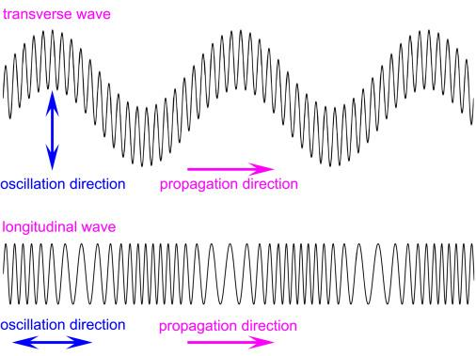

## **12.6.2 Longitudinal Waves**

In longitudinal waves, particles vibrate parallel to the direction of wave propagation. Compressions (high pressure) and rarefactions (low pressure) form along the direction of energy flow. Examples include sound waves and seismic P-waves.

**Examples of Longitudinal Waves:**

**Sound Waves**

* Sound is a longitudinal wave produced by vibrating objects (e.g., vocal cords, tuning forks).
* Compressions and rarefactions propagate through air or another medium, transferring energy as pressure variations.
* The human ear interprets these vibrations as audible sound.

**Seismic P-Waves**

* Primary (P) waves are seismic longitudinal waves.
* They cause particles of rock to compress and expand in the same direction as wave travel.
* P-waves are the **fastest seismic waves**, arriving first at seismic detectors.
* Unlike S-waves, they can travel through **solids, liquids, and gases**.

# **12.7 Wave Characteristics**

• Wave Cycle: One complete oscillation of a particle as the wave passes. It is denoted by $N.$  
 • Frequency **(f)**: Number of cycles per second; **unit is Hertz (Hz)**. Mathematically, it is

$f= \frac{N}{t}$ or $f= \frac{1}{T}$

• Time Period **(T)**: Time for one complete cycle; **unit is seconds (s)**. Time period is the reciprocal of Frequency. Mathematically:

$T= \frac{1}{f}$• Wave Speed **(v)**: Distance travelled by a wave per second; unit is **meters (m)**. Given by universal equations:

$v=\frac{λ}{T}$ or $v=fλ$

# **12.8 Properties of Waves**

Waves display behaviors such as reflection, refraction, and diffraction. A ripple tank is often used in experiments to demonstrate these properties.

A ripple tank is a shallow tank of water with a transparent base used to demonstrate wave properties.

* A light source shines from above so that waves formed on the water surface cast shadows on a screen below, making them visible.
* A motor-driven dipper generates periodic disturbances (circular or straight ripples).
* By placing barriers, gaps, or slopes inside the tank, one can demonstrate:

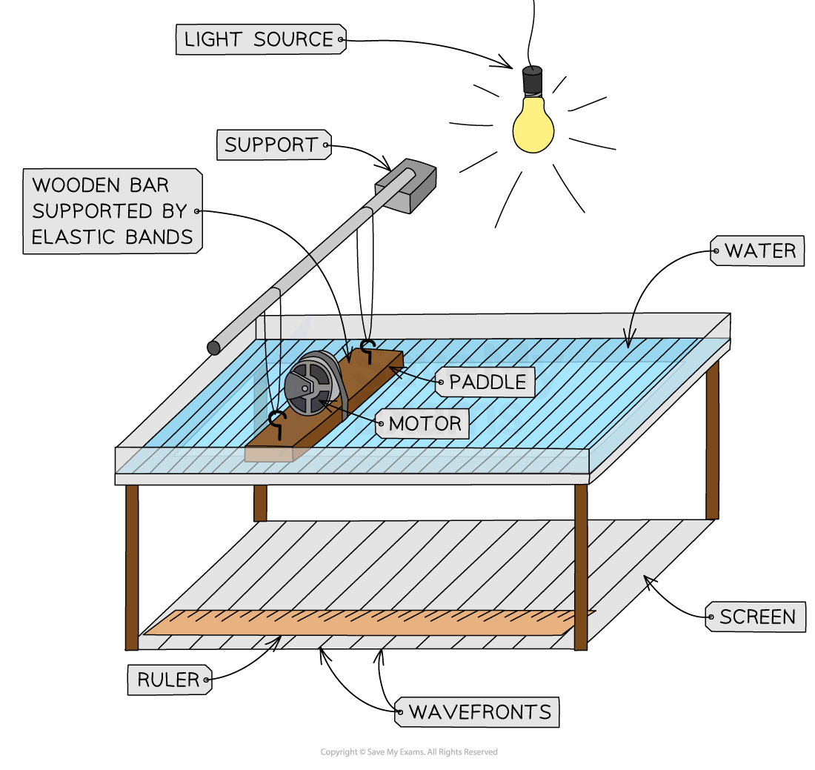

## **12.8.1 Reflection**

Reflection is the bouncing back of waves after striking a surface or boundary. In ripple tanks, waves reflect back when they hit a rigid barrier.

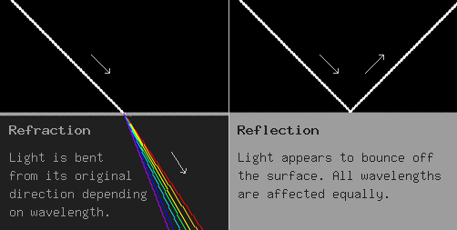

## **12.8.2 Refraction**

Refraction is the change in direction of waves when they move from one medium to another due to a change in wave speed. In water waves, entering shallow water reduces their speed and wavelength, bending the waves.

## **12.8.3 Diffraction**

Diffraction is the bending and spreading of waves around obstacles or through narrow gaps. Diffraction is more pronounced when the wavelength is comparable to or larger than the gap size.

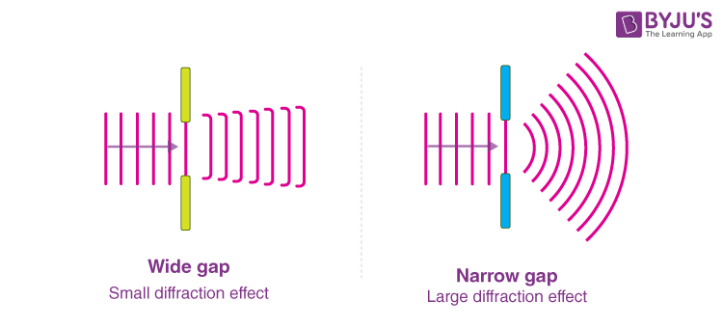

**Relation between Diffraction and Wavelength**

* Diffraction becomes more significant when the **wavelength is large** compared to the size of the gap.
* Longer wavelength waves (like sound) diffract more easily than shorter wavelength waves (like light).

**Relation between Diffraction and Gap Size**

* If the **gap size is much larger than the wavelength**, diffraction is minimal (waves mostly pass straight through).
* If the **gap size is similar to or smaller than the wavelength**, diffraction is pronounced, and waves spread widely.

# **12.9 Tsunamis**

Tsunamis are destructive waves caused mainly by underwater earthquakes, volcanic eruptions, or landslides. In deep oceans, they travel rapidly with low amplitude, but near shorelines their height increases dramatically.

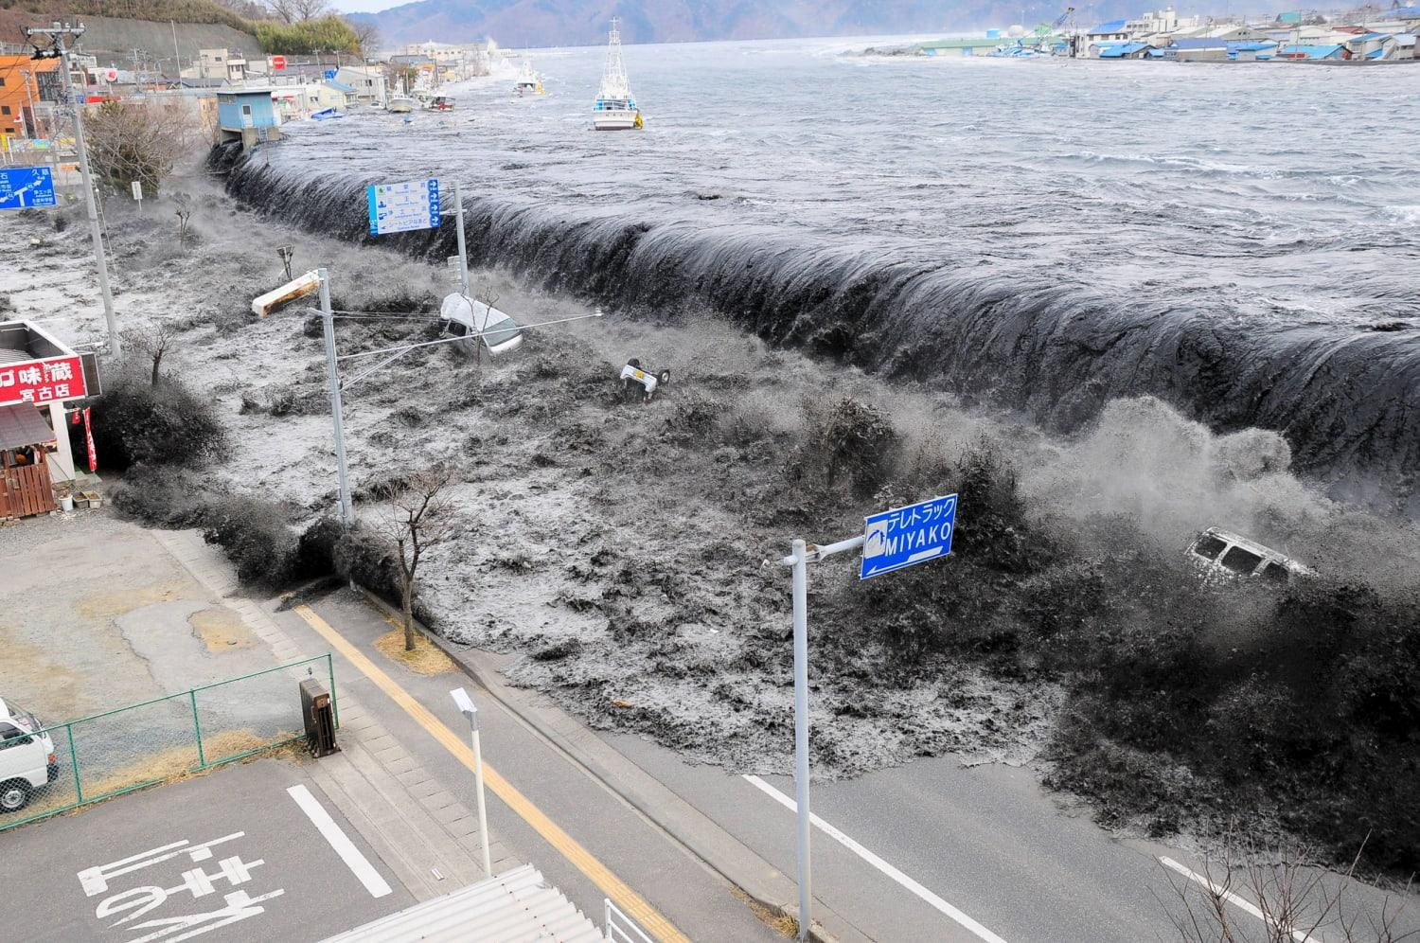

## **12.9.1 Tsunami Generation Process**

Tsunamis are a series of enormous ocean waves caused by earthquakes, underwater landslides, volcanic eruptions or asteroids. Usually, tsunamis are generated when the ocean floor is suddenly displaced due to tectonic activity, causing a massive movement of water. The energy spreads outward as long, powerful waves.

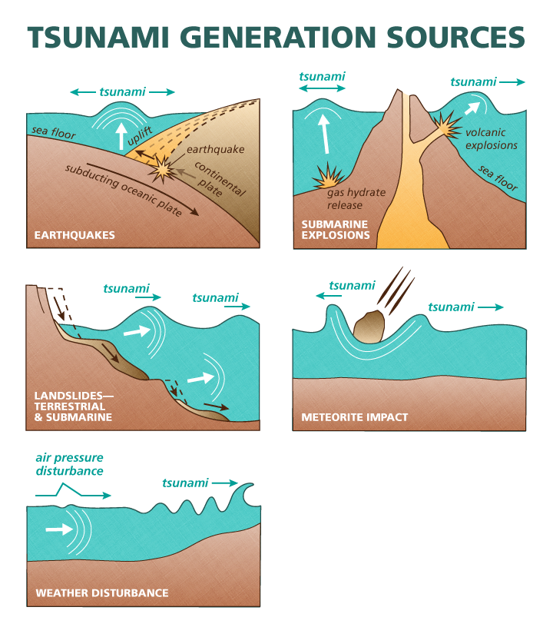

## **12.9.2 Characteristics of Tsunami**

• Travel at speeds of 500–800 km/h in deep water.  
 • Appear small in open oceans but rise to enormous heights near coasts.  
 • Can cause massive flooding, destruction, and loss of life.

